FINDING YOUR NICHE
Suggested time: Sunday Morning
Best location: Any quiet spot where you can reflect and self-evaluate

That Elusive Niche
Most people don’t find their niche right away – some take years plus several trial and errors before they can get hold of it.
This activity aims to point you in the right direction because you must have a prospective niche to proceed with this course.
It’s very important that you take this activity SERIOUSLY because your success lies here.
We can’t check if you answered this activity correctly or not.

The only way we’ll know is when we see you reaching your goals and living your ideal life SOON.
If you have been doing the past worksheets at the last minute or,
If you were half-heartedly answering them simply for the sake of submitting…
STOP! Not. Now. Please.
For this activity to work, you’ll need to allocate at least an hour for self-evaluation.
This will be the only worksheet that has time/place recommendations and suggested stops.
Find a quiet place where you cannot be disturbed, where there are no distractions.
Put your phone on silent just for an hour and wear your noise-canceling earphones if there’s a lot of background noise.
Just for an hour, be in a place where you can be still and truly have an honest conversation with yourself…
It’s true that finding your niche is not easy, but there are clues already inside you.
Let’s do a personal scan and check for these clues one by one.
#1: Your interests and passion
What sparks your interests? What makes you burn with passion?
You may have noticed how people differ in the things or activities they’re interested in, depending on personality, culture, and preferences.
Your interests and passion are there for a reason. When used properly, they can guide you towards your purpose.
Evaluate yourself:
When you’re browsing the internet during your free time, which sites do you usually check?
What articles do you usually read?
What forums are you most active in?
What newsletters are you subscribed to?
Which topics excite you so much that you can’t help but click any related links you see?
#2: Your skills and talents
You might have been born with a gift of fixing broken things, or maybe you can naturally sing wonderful melodies when you’re bored – those are talents.
You might have learned how to sew clothes during Home Economics class, or maybe you taught yourself how to build websites from reading tutorials online – those are skills.
Your talents weren’t just given to you for nothing. You’re wired to do or learn something BETTER than others because it helps with your purpose. (You may or may not know what that purpose is right away, but you can use these as hints in finding your niche.)
Evaluate yourself:
What are you good at?
Grab your SWOT Analysis worksheet from Week 1, what did you write under Strengths?
Which areas do you usually excel in?
What topics or subjects do you find easy to understand?
What do most people ask you for help for?
What problems do you solve for people?

#3: Your background and experiences
Sometimes, life takes you away from your passion and talents. You might have had to study courses or accept jobs that weren’t aligned with your interests and skills because they made sense at that time.
But like they say, everything happens for a reason. Your background and experiences may be nudging you to a certain direction, or they may be preparing you towards your niche.
Evaluate yourself:
What did you study in college?
What clubs or organizations were you active in?
List down the companies that you’ve worked for. Which skills did each of them train you to be good at? (Example: Jollibee – Customer Service, Efficiency (fast-paced environment), working with a team)
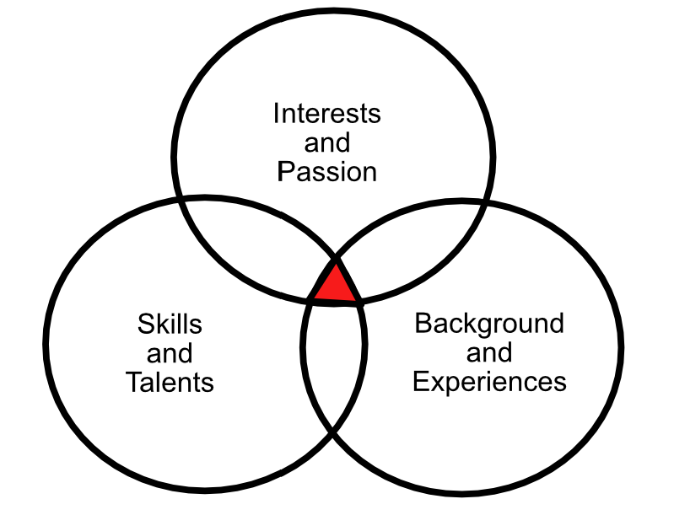
Now, compare all your answers and encircle what is common among all 3.

Look at the diagram above. The intersection between all three circles is what we call your “Niche Triangle.”
No, that triangle isn’t your niche yet.
But those skills/traits are definitely involved with your niche.
List all the traits/skills in your Niche Triangle.
The Reversal Technique
Since we know that your niche pretty much involves everything in your Niche Triangle, it makes sense that following the triangle will ultimately lead to your niche. Let’s do some reverse engineering and find out where it takes us.
Look at your Niche Triangle. Write down all the possible fields/industries that could benefit from your Niche Triangle.
(Don’t overthink this step. It doesn’t matter whether you need to learn more skills or if you don’t think you have enough experience in a certain field yet. If you feel that you can help them out using your Niche Triangle, then go ahead and write them down.)
Possible Fields/Industries that I could Help
(Niche Prospects)
(Example:

Strength Triangle – talented in writing, used to work in a shoe store, addicted to reading about the latest shoes

Possible fields: I can write articles for online store owners who sell shoes. )
Note:
If you’re having difficulties answering this, please share your Niche Triangle in your Slack Mastermind Group Your classmates and I will do our best to help you out.

