Researching and Testing your Niche Prospects:

- Is there a need for it?

- Do an advanced search on Upwork using their skill and word filters.
- How many clients are looking for those skills?

- Look at your target jobs on Upwork.
- What do clients usually look for?
- What additional skills do they require? What experiences do they require? Copy and list the requirements.

Example:
Niche Prospect: Print Layout Design
Number of Jobs: 1,777
Related Skills: Adobe InDesign, Graphic Design, Print Design, Adobe Illustrator, Adobe Photoshop
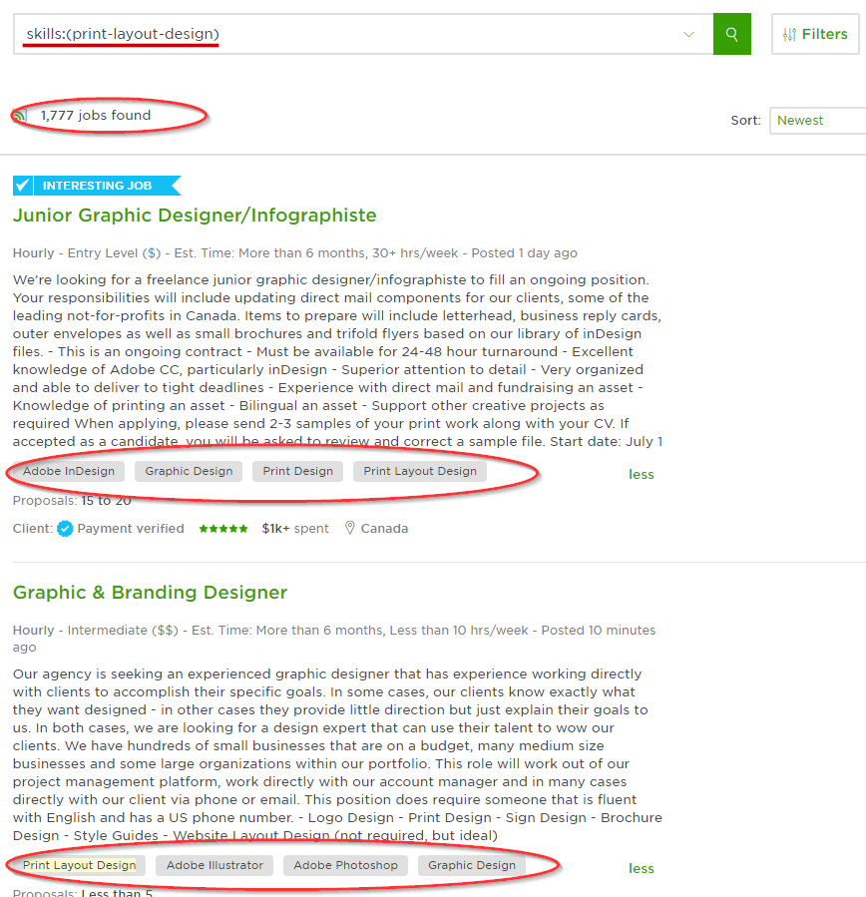
Experience Required: Entry/Intermediate Level

Niche Prospect | Research Results
Number of Jobs:
Related Skills:

Experience Required:
Number of Jobs:
Related Skills:

Experience Required:
Number of Jobs:
Related Skills:

Experience Required:
Number of Jobs:
Related Skills:

Experience Required:
Number of Jobs:
Related Skills:

Experience Required:
Number of Jobs:
Related Skills:

Experience Required:
Number of Jobs:
Related Skills:

Experience Required:

- Have other people profited in any of these niches?
Is there anyone who has become a successful influencer in this niche?
What did he/she do to get to this point?
What courses/training did he/she take?
Does he/she have a personal blog?
Has he/she written a book?
Do a research (stalk) about his/her journey. If possible, get in touch with him/her for an interview. Pick his/her brains and plot helpful steps you could use on your own journey.

Notes:

Filtering Prospective Niches:

Based on the results of your niche research, follow your gut and list down the top 3 prospective niches you feel good about.
If you’re torn between more than 3 prospective niches, you might need to niche down. (If you need help niching down, please post in your Slack Mastermind Group)
Now, list your Top 3 Prospective Niches here:
1. ____________________________________________________________
2. ____________________________________________________________
3. ____________________________________________________________

