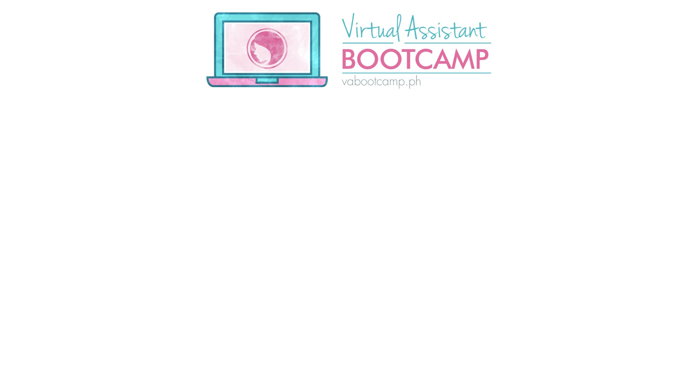

Next Level Freelancing 102
____________'s Personal Study Guide
Use this as your personal guide in order to complete all the modules and action items within the next 3 weeks. We've pre-plotted rest days on Saturdays and Sundays so you won't feel burned out but feel free to make adjustments to the schedule based on your preference and availability. This calendar also assumes that Day 1 is a Monday, but you may adjust accordingly. With this schedule, allocate between 30mins to 1 hour per day to take the lessons. Print this calendar and put a check mark next to the lessons that you've completed as you complete them. That way, you can track your progress. Alright. Let's go!

START DATE __________________ COMPLETION DATE __________________

Sun | Monday | Tuesday | Wednesday | Thursday | Friday | Sat
 | 1 | 2 | 3 | 4 | 5 | 6
Date
 | 1.1. Intro  1.2 Review KLT | 1.3Influence  Action Items | 1.4Platforms  Action Items | 1.5 LinkedIn | 1.6 Own Website  Action Items
7 | 8 | 9 | 10 | 11 | 12 | 13
Date
 | 2.1 Case Story  Action Items | 2.2 Free Work  Action Items | 3.1 Leads | 3.2 Warm and Lukewarm | 3.3 Using Forums
14 | 15 | 16 | 17 | 18 | 19 | 20
Date
 | 3.4 LinkedIn  Action Items | 3.5 Cold Emails  Action Items | Complete Action Item 2.1 (after 7 days) | 4.1 Discovery Call  Action Items | 4.2 The Proposal  Action Items
21 | 22 | 23 | 24 | 25 | 26 | 27
Date
28 | 29 | 30 | 31
Date

